I use more detail plots with less words, as there is a restriction. I will try to prove concepts of the Law of Large Numbers and Central Limit Theorem using non-symmetric population distribution.

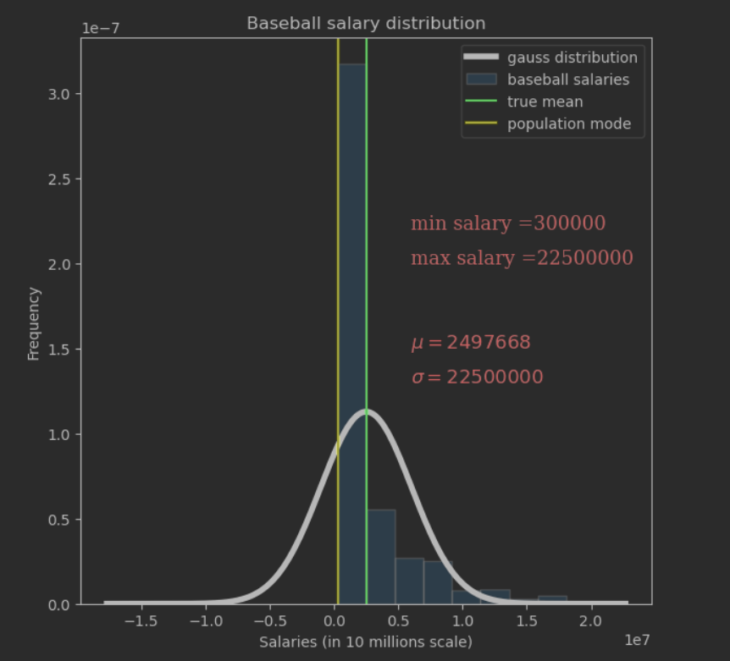

Looking at the “Baseball salaries” population distribution, we can notice a non-symmetrical ‘skewed right’ distribution. There is no clear point for “center” of distribution. We can identify the most of distribution is concentrated in the group between the population mode and population mean, and more precisely between the lowest salary $300,000 and the true mean $2,500,000

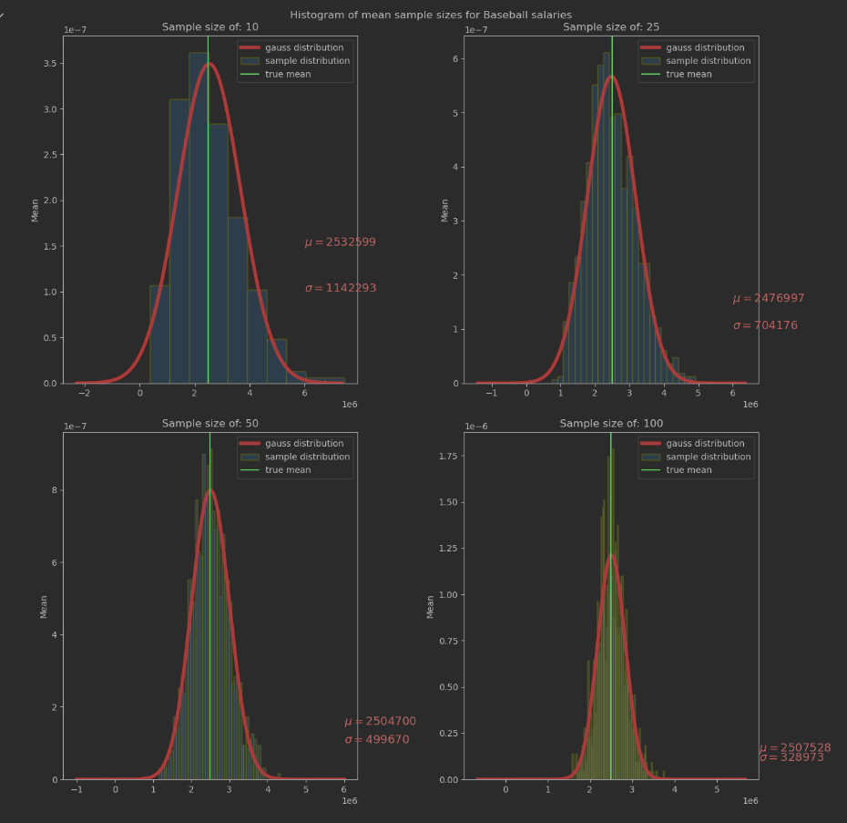

From the above plot we can see that with an increase of the sample size distribution changes its shape, we observe a principle of the Low of Large Numbers as sample size grows, its mean (sample) gets closer to the average of the whole population ( true mean).

We also observe a principle of Central Limited Theorem which says that as sample size increases, the sample distribution becomes closer and closer to a normal distribution(symmetric Gaussian distribution)

The sample mean decreases with increase of the sample size. Also we observe decrease in standard deviation with rate of 𝜎^2/𝑛 and the variance of the sample, as example plot with sample size=100

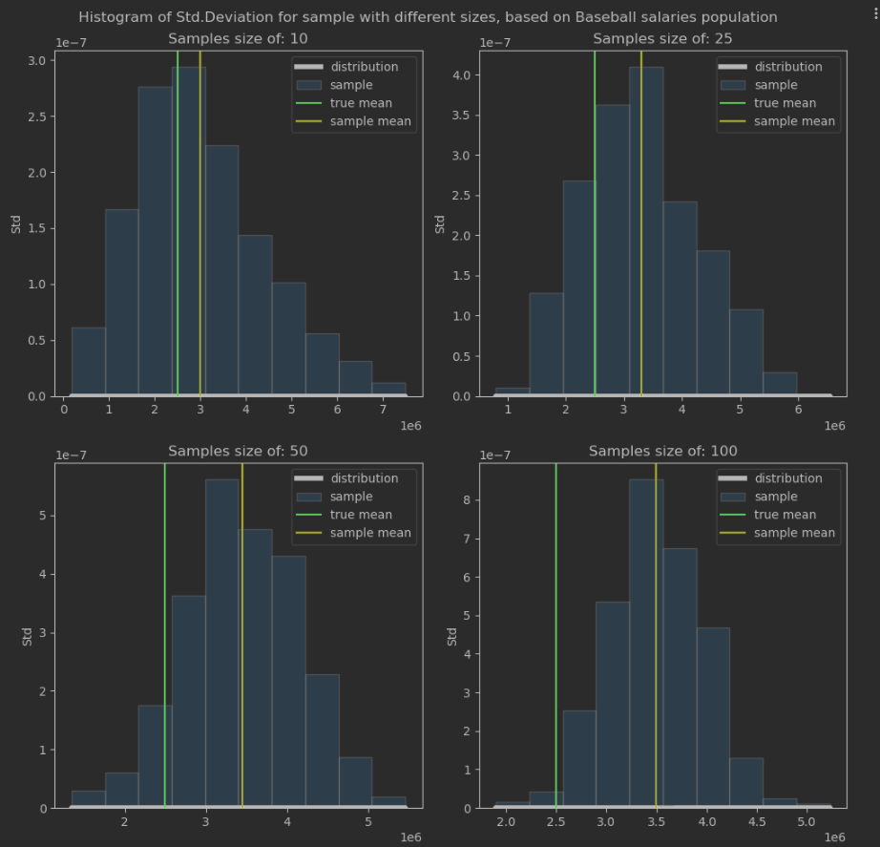

From the above plot we can see that distributions are not symmetric (no center of distribution) and with an increase of the sample size we observe decrease of sample standard deviation sigma.

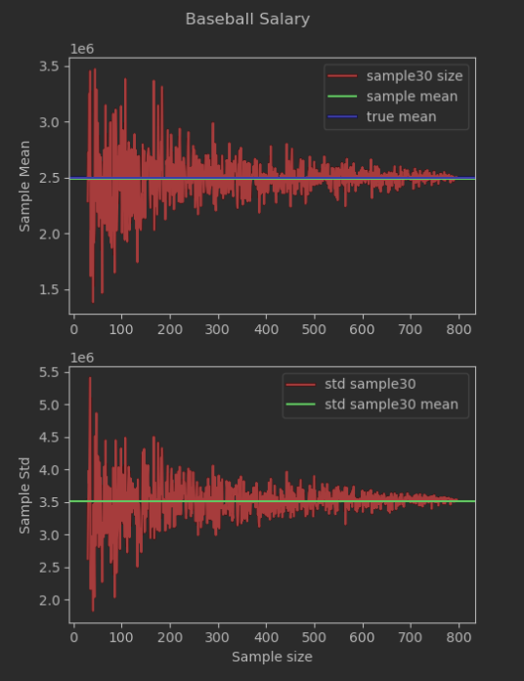

The above plot proves the theorem of Law of Large Numbers that as a sample size grows, its mean gets closer to the average of the whole population. That sample size is based (range(30, len(baseball_salary[‘salary’])) on the Statisticians findings as 30 is a pretty good general threshold. So if you have a sample size of 30 or more, you can assume that the distribution of its mean is normal without having to know much about the process that generated the numbers, beyond that the end samples were taken independently.

the variance of the sample mean decreases as 𝜎^2/𝑛.

the central limit theorem tells you about its shape. It says that as 𝑛 increases, 𝑋̅𝑛 becomes closer and closer to a normal distribution.